Name ______________________________________________ Period __________ Date __________________

**Math 2 Intro to Geometry Review Homework**

**Geometry Basics Review**

1. What is the difference between a line, a ray, and a segment? Draw one of each containing points A and B.

2. Draw an obtuse triangle. 3. Find the midpoint and the length of the segment below.

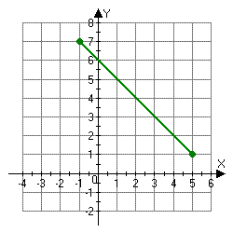Then use a protractor to find Show your work using the distance and midpoint formulas.

all of the angle measures.

4. Use the Pythagorean Theorem to find the missing side of each right triangle. Show your work.

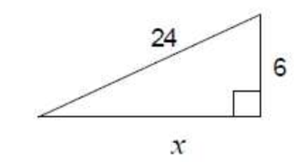 a. 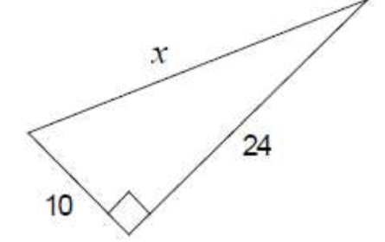 b.

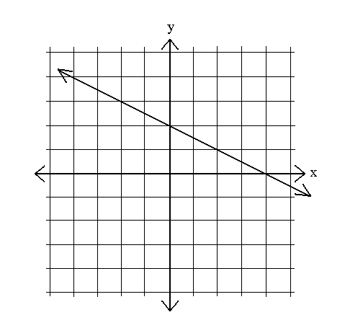**Parallel and Perpendicular Lines Review**

1. Write the slope of the line parallel to each line below:

a. b. passes through and c.

2. Using the same lines as in #1, write the slope of the line perpendicular to each line above.

a. b. c.

**Transformations Review**

Find the new vertices of after performing each transformation. Show the graph of the transformed image.

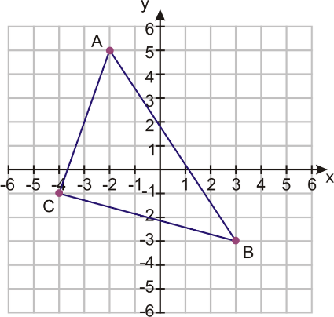1. Reflect over the x-axis. 2. Reflect over the y-axis.

3. Translate right two, down 3. 4. Rotate counterclockwise.

5. Rotate counterclockwise. 6. Rotate counterclockwise

7. Dilate by a scale factor of ½. 8. Tranform using the rule